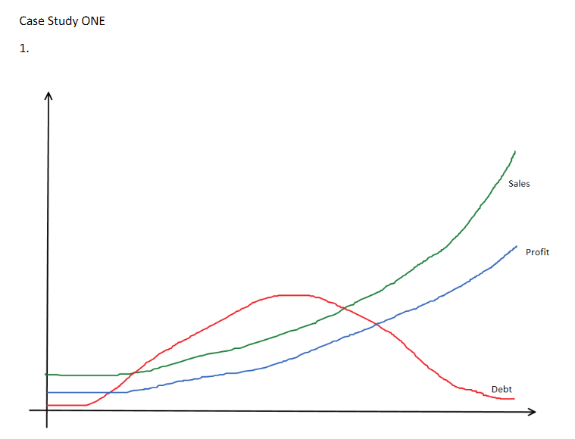

**TASK ONE, CASE STUDY ONE GRAPHS**

**Alt text:**

Graph of sales, profit, and debt; sales and profit lines rise, left to right, and debt line rises and then falls.

**Long description:**

Sales line begins at y-axis slightly above x-axis and rises smoothly in a concave curve to a high point at far right near the top of the graph. Profit line begins slightly below sales line at y-axis and parallels the sales line to high point at far right about half the graph's height. Debt line begins at the y-axis very near the x-axis, crosses the sales and profit lines to a high point at the lower third of the height of the graph, midway along the x-axis, then falls at far right to near x-axis.

1

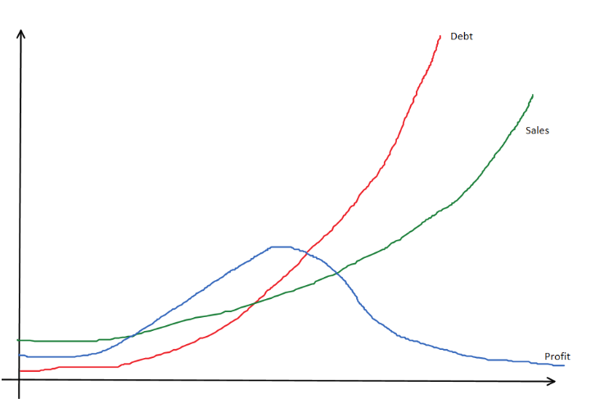

**Alt text:**

Graph of sales, profit, and debt; debt and sales lines rise, left to right, and profit line rises and then falls.

**Long description:**

Sales line begins at y-axis slightly above x-axis and rises smoothly in a concave curve to a high point at far right near the top of the graph. Profit line begins slightly below sales line at y-axis and crosses the sales line to a high point at the lower third of the height of the graph, midway along the x-axis, then falls at far right to near x-axis.

Debt line begins at the y-axis very near the x-axis and rises sharply to a high point at far right to near top of the graph.

21

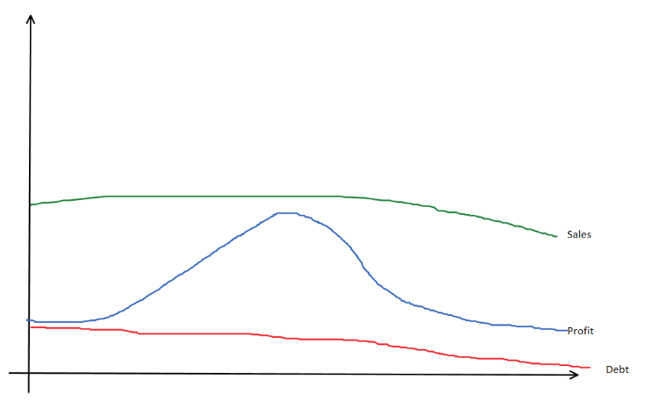

**Alt text:**

Graph of sales, profit, and debt; debt and sales lines fall, left to right, and profit line rises and then falls.

**Long description:**

Sales line begins at the midpoint of the y-axis and gradually falls to a slightly lower point at far right. Profit line begins at y-axis a bit above the x-axis, rises sharply to a high point midway along the x-axis, just below the sales line, then falls to a point at far right to a level close to its starting point. Debt line begins at the y-axis just below the profit line and gradually falls to a point very close to the x-axis at far right.

31

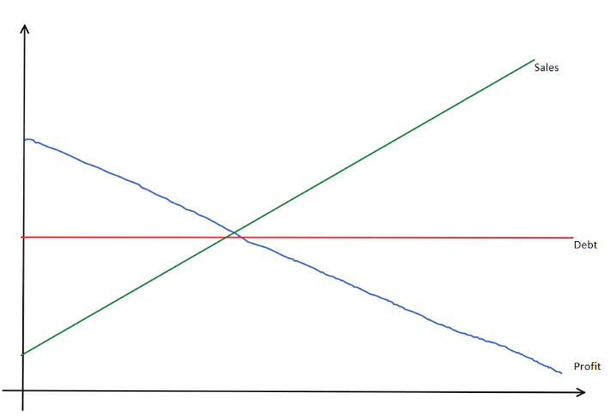

**Alt text:**

Graph of sales, profit, and debt; sales line rises sharply, profit drops sharply, and debt remains unchanged.

**Long description:**

Sales line begins low on the y-axis and rises sharply to high point near top of graph at far right. Profit line begins moderately high on the y-axis and falls sharply to a low point at far right near the x-axis. Debt line begins at midpoint on the y-axis and remains unchanged to its endpoint at far right.

41

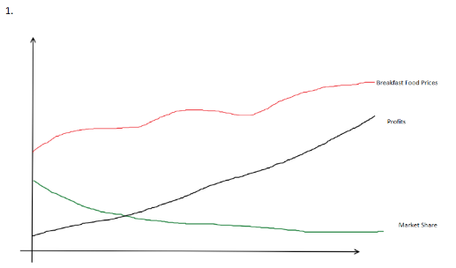

**TASK ONE, CASE STUDY TWO GRAPHS**

**Alt text:**

Graph of breakfast food prices, profits, and market share; prices rise overall, profits rise sharply, and market share falls.

**Long description:**

Breakfast food prices line begins at midpoint of y-axis and rises and falls several times, rising overall to a high point at far right about a third from the top of the graph. Profits line begins just above y-axis and rises smoothly to point at far right about at the middle of the graph. Market share line begins at the y-axis very near the x-axis, crosses the sales and profit lines to a high point at the lower third of the height of the graph, midway along the x-axis, then falls at far right to near x-axis.

1

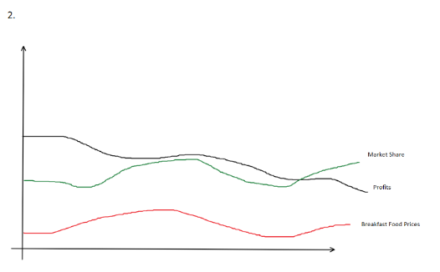

**Alt text:**

Graph of breakfast food prices, profits, and market share; all lines rise and fall, with market share alone ending higher.

**Long description:**

Breakfast food prices line begins low on y-axis, rises, falls, then rises again to end at about its original level. Profits line begins at about midpoint on the y-axis and falls at far right by about 20% of original level. Market share line begins at about one-third up on the y-axis, rises and falls, and ends at far right slightly higher than original level.

21

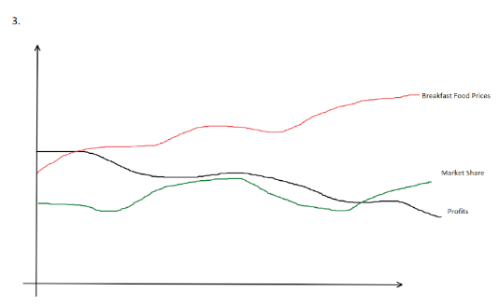

**Alt text:**

Graph of breakfast food prices, profits, and market share; all lines rise and fall and prices and market share end higher.

**Long description:**

Breakfast food prices line begins about midpoint on the y-axis, rises, falls, then rises again to end significantly higher than its original level. Profits line begins at about midpoint on the y-axis and falls at far right by about 20% of original level. Market share line begins at about one-third up on the y-axis, rises and falls, and ends at far right slightly higher than original level.

31

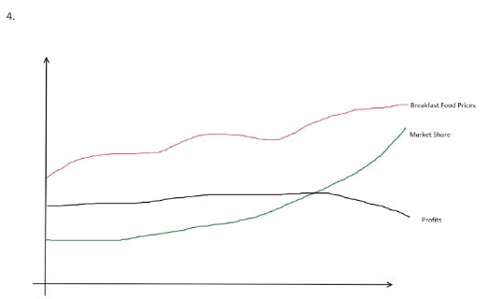

**Alt text:**

Graph of breakfast food prices, profits, and market share; prices and market share lines rise, and profits fall overall.

**Long description:**

Breakfast food prices line begins about midpoint on the y-axis, rises, falls, then rises again to end significantly higher than its original level. Profits line begins at about midpoint on the y-axis, rises slightly, then falls to slightly below original level. Market share line begins at about one-quarter up on the y-axis and rises smoothly to a point at far right significantly higher than its original level.

41